J.W. Birney Family
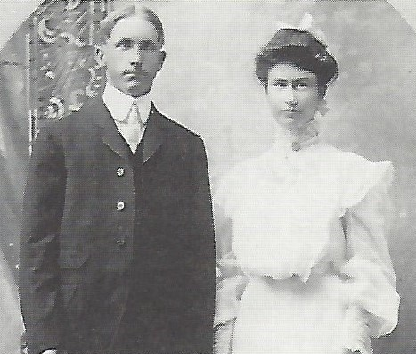
Joseph William and Nellie Gardiner Birney wedding

J. W. Birney and Nellie Gardiner were married at Kingman, KS July 19, 1905. They came to a farm southwest of Mullinville where they lived until 1924.

They had six children who are Merle E. Birney of Dodge City, Judge C. E. Birney of Hill City, Mrs. Lucille (Clarence) Sprout of Greensburg, Mrs. Leona (W. A. Nickell) of Dodge City, Lawrence (Phyllis) Birney of Boca Raton, Florida; and Vern (Kathryn) Birney of Bucklin.

When Mr. Birney was a young man he took care of cattle for the late George T. Donaldson of Greensburg and J.W. Glover of Mullinville. There were times when he fed as many as 700 to 800 head of cattle at his farm. He worked for them until he was able to go into the ranching business for himself.

His father bought several quarters of land southwest of Mullinville across into Ford County. He rented this land to his 9 children and when the estate tax law was passed he gave each of his children a quarter of that land. J.W. was the only one of the family to own and farm the quarter he was given when he died. His son Vern now farms the land. Whenever J.W. could buy more land in better times he bought five quarters close to the land he owned.

In 1922 he rented 2 sections of grass land north of Bucklin on the river, which he later bought. In 1924 he rented a farm west of Bucklin because of having three children in high school and two car families did not exist in that day.

During the year 1922 he leased Drake Ranch and 1923 he leased the Eastman Ranch south of Bucklin. He operated the Drake Ranch as his headquarters. When times were good in the 20’s he had around 2500 to 3000 head of cattle. He farmed two farms and had an implement store in Bucklin. During the 30’s he lost the cattle and the ranch leases but kept the farm land and bought more of the land which sold cheap on the river.

In 1937 they moved into Bucklin. He never lost his pride and strength to make money again. He wanted all of his children to have a college degree. Three of them have college degrees and all attended college. He took much pride in serving his community and served on school boards, CO-OP boards, and served as the mayor of Bucklin for several years. He always said he went broke once and he could do it again.

During the 30’s he was inspector for the Regional Agricultural Corporation which later became the Production Credit Association. He was inspector for PCA for several years. That helped put the food on the table.

The J. W. Birney farmstead was located ¾ mile west and one mile south of the Fromme-Birney Round Barn. The J.W. Birney barn was listed as an “honorable mention” (as was the Henry W. Fromme Round Barn) in the Kansas Board of Agriculture photo contest and the photo was in the 1917-18 Kansas Department of Agriculture Yearbook of Agriculture. This book incorrectly listed the J.W. Birney barn as being in Ford County.

J. W. Birney purchased the round barn from the Fromme family in the 1954. The Fromme home was in poor condition and was removed in the 1950s. Mr. Birney died in Nov. 1959 and Mrs. Birney in August, 1961.

Larry (Lawrence) Birney received the barn and surrounding quarter of ground from the J. W. Birney estate.

Larry’s brother, Vern Birney farmed this quarter section where the round barn is located and the barn was used for hay storage and to shelter some cattle in the winter. Vern was a community leader and long-time county commissioner in Ford County.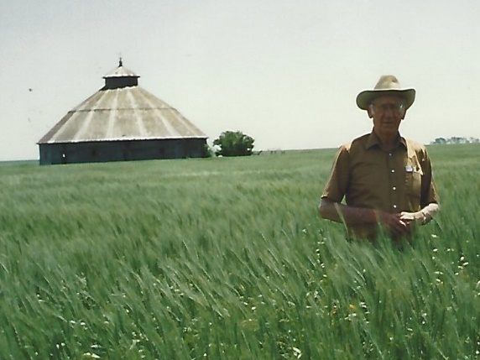
(Vern Birney, 1986)

After Larry and Phyllis Birney were married in 1970, Larry took his new bride to Kansas. Phyllis was captivated upon the beauty of the barn at the first site of its cathedral like ambience. Due to her continued fascination with this architectural wonder, Larry gave Phyllis the barn and one acre to Phyllis as a 15th wedding anniversary gift in 1985.
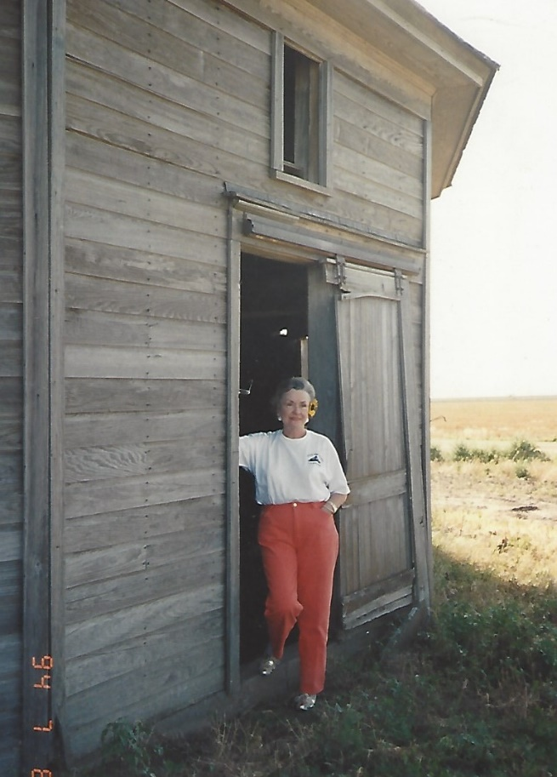
(Phyllis Birney, 1994)

Upon receiving the barn, Larry and Phyllis started the extensive research on the construction and design of the barn in order to get it listed on the National and State Register of Historic Places. Their work was successful in 1987 when the barn was listed as the Fromme-Birney “Round” Barn. Restoration was the dream, but due to Larry’s failing health and costs of estimated repairs delayed the barn repairs. Larry Birney died in North Carolina in May of 1992.

In December of 1993, Mrs. Birney gave the barn and surrounding acre to the Kiowa County Historical Society who had formed a Round Barn Restoration Committee. Phyllis Birney maintained an interest in her beloved barn until her death in May, 2017.

