Kansas State Board of Agriculture
Eighteenth Biennial Report. - - Part II.
1911-1912
(pgs. 229-325)
PERCHERON BREEDING IN KANSAS

By Wayne Dinsmore, Secretary Percheron Society of America, Chicago

Draft-horse breeding is centered in the six big corn belt states, Ohio, Indiana, Illinois, Iowa, Nebraska and Kansas. These are likewise the leading Percheron states, contributing more than 72 per cent of the Percherons bred in America.

Kansas stands fourth in total number and value of horses. She also occupies fourth place in pure-bred Percherons. The last census credits the state with 1,147,056 horses, valued at $112,756,108. Figures recently compiled by the Percheron Society of America show that 10,758 American-bred Percherons were recorded between August 1, 1910, and May 1, 1912. Of these 627 were bred in Kansas and the state contributed 5.8 per cent of all recorded in the time mentioned.

The accompanying map shows at a glance the distribution of Percherons in the state by counties. It also shows the percentage each county contributed to the total for the state, and the number of members of the Percheron Society of America. Butler, Harvey, Mitchell, Barton, Cowley, Sumner and Phillips are the first seven counties, ranking in the order named. Together they contributed 38.4 per cent of all those bred in the state.

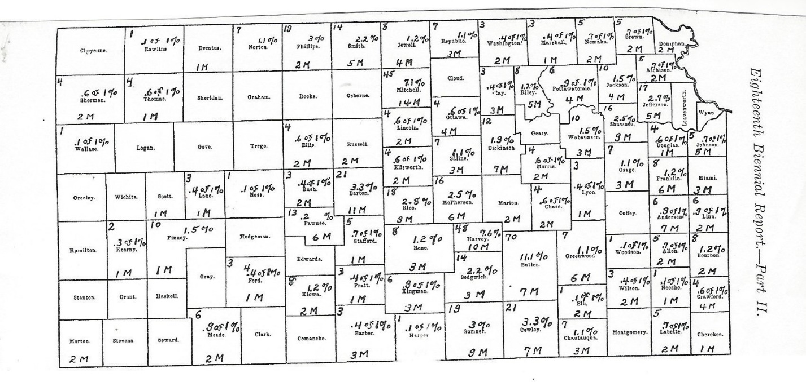

Map showing the distribution of Percherons in Kansas, per cent of total number bred in each county and recorded between August 1, 1910
and May 1, 1912. “M” indicates members of the Percheron Society of America

It will be noticed that the distribution is very considerable, as Percherons are being bred in 72 out of the 105 counties, and no one county has any marked advantage over others, although the first two counties, Butler and Harvey, together contributed a little over 18 per cent of those bred in the state. These first seven counties constitute three separate groups: one in the south-central part of the state, one in the central part, and one in the north-central part of the state. Mitchell county enjoys the honor of having the strongest county breeders’ association in the state. This has been in existence for some three years, and has already accomplished a great deal, particularly in encouraging farmers throughout the county to purchase excellent individuals of pure breeding.

The breeding of Percherons in Kansas has been carried on for about thirty years. The first authentic importations were made prior to 1876, by M. J. Parrott, of Leavenworth, Kan., Wm. Dengel, of Salina, took Vidou 953to the state in 1881.
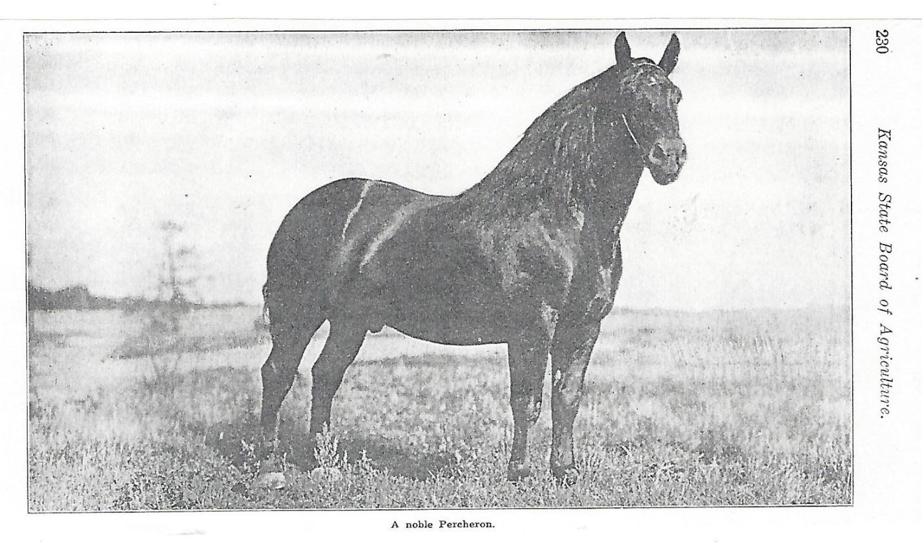
There were other scattering purchases within the next few years. J.W. & J.C. Robison, of Towanda, took a number to the state in 1885. This stud has been maintained to the present, and is now one of the noted breeding establishments of the United States.

The general distribution of Percherons in Kansas may be said to have begun about 1885, and breed interests have grown steadily since that time. Their popularity in Kansas is attested by the fact that out of 2387 pure-bred draft stallions standing for service in the state in 1911, 1733, or 72 per cent, were Percherons. This appears to be a higher proportion of Percherons than is found in any other state. These figures were supplied by C.W. McCampbell, of the Kansas State Stallion Board.

Comparison of the total number of horses with the total number of pure-bred draft stallions reveals that there is but one pure-bred draft stallion per 480 horses. This means only about four sires per 2000 horses. Experienced horsemen know that this is not half as many as are needed to permit every farmer to have ready access to a good sire. The need for additional pure-bred horses of the right kind is manifest. The opportunity is before Kansas Percheron breeders.

Strong county breeders’ organizations are to be recommended, and will stimulate the production of more and better draft horses. The first step in this is to establish a good market for the horses produced in that particular locality, by advertising and drawing buyers to the breeders, whether they are handling pure-bred horses or not. The farmer who is raising grade draft horses is encouraged to produce better ones if a good market is afforded for those he has proportioned geldings that will weigh 1650 pounds or over at four years of age. Buyers for the Southern states and for the West and Northwest will take all the surplus mares of this kind at good prices.

The character of Percherons produced in the county can be improved by the work of such local organizations. Colt shows can be started, and these encourage small breeders to take better care of their young stock, which is a most important point. In the judgement of a large proportion of the most experienced horsemen, 90 per cent of our Percheron breeders do not feed their colts, yearlings and two-year-olds liberally enough. Pure-bred draft colts should have a creep where they can secure good oats or a mixture of corn, bran and oats, whenever they want it. The local organization, through colt shows, can demonstrate the necessity of extra liberal feeding and the profit accruing thereby. Scrub stallions are automatically eliminated. The inferiority of their produce, manifest when brought into deadly parallel with the product of first-class pure-bred sires, brings an abrupt end to their career.

These and other practical measures of improvement can be wrought out by a strong county horse breeders’ association. Annual dues of $5 or $10 from each member will permit the local association to compile and publish a booklet giving a list of all pure-bred draft horse breeders in the county, with a statement as to the number of pure-bred horses owned by each, and what surplus there is available for sale. It will also provide for a small, clean-cut advertisement in one or two of the leading agricultural papers covering the territory in which sales are sought. Inquiries resulting from such advertising can be answered by the local secretary, briefly but clearly, by means of printed information which he should have available to mail out to such prospects. By united work along these lines small breeders can secure, at slight cost, publicity of the right kind, which will give greatly increased opportunities for selling surplus colts at good prices.

In production, breeding and feeding are the two essentials. Good foundation stock, possessing size, draft conformation and soundness, is the first requisite; but such foundation stock avails nothing unless the animals produced are given a full opportunity, through extra liberal feeding, to develop. The value of the oat bin cross is more fully understood in France than in America. The aim needs to be, in growing pure-bred draft colts, “not how cheap, but how good.” Efficient production simplifies distribution. Buyers once attracted to a locality by proper advertising will never forget the district if they find first-class horses.
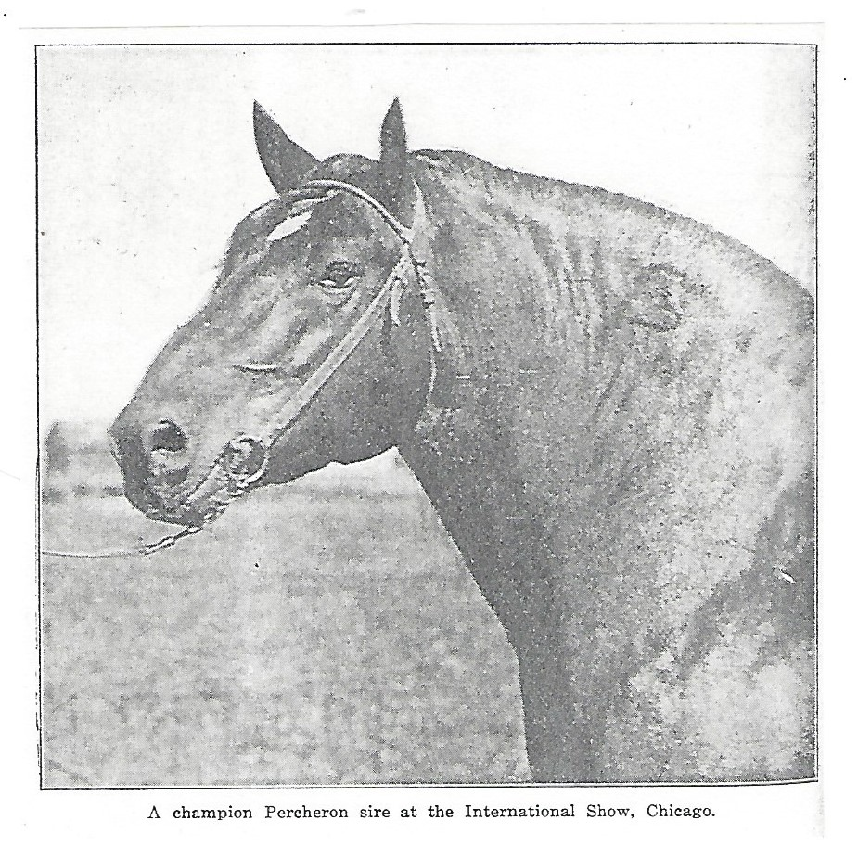
Kansas has as great opportunities for the breeding of good Percherons as any state in the Union, and many good judges consider that the combination of corn, oats, alfalfa, abundant water and rolling land gives the state an advantage over any other district of the same size in the United States. Certain it is, that at the present day there is probably no state where so
large a proportion of the draft horses are of Percheron breeding. The Agricultural College has the soundest stallion law enacted in any state. Selection and purchase of good foundation
stock is relatively easy; soil and climatic conditions are most favorable; attention to essential points and production and united work in marketing the surplus stock will enable the state to hold its present strong position in Percheron breeding, and it may in time attain an even higher rank than it now holds.

